**FOOD INSECURITY IN THE UNITED STATES IN THE YEAR 2018 AND 2019**

**INTRODUCTION**

Lack of continuous access to enough food for every member of a household to live an active, healthy life is known as food insecurity. A household may be in this predicament for a short while or for a very long time. One indicator of how many people cannot afford food is food insecurity.

As a fellow food blogger, I was motivated to pick a research topic related to the food sector.

**About the data set and sources:**

I have gathered the data based on several metrics like food insecurity, physical health, income and employment, ethnicities, housing, and transportation costs of the years 2018 and 2019 from various data sources mentioned below:

**Tables**

1. Food insecurity: This table consists of data related to food insecurity in 2018 and 2019
2. Demographics: This table consists of data related to different ethnicities, races, immigrants, total population, population in urban areas.
3. Physical health: This table consists of data related to people having various health conditions like diabetes, disabilities, people giving birth to low-weight babies and deaths.
4. Financial health: This table consists of data related to debts and credit scores
5. Income and Employment: This table consists of data related to annual income and unemployment rates.
6. Income and Transportation: This table consists of data related to housing costs, transportation costs and wages to afford fair market rents.

**Sources:**

1. Credit bureau
2. US Census Bureau’s decennial census and American Community Survey (ACS);
3. Center for Disease Control (CDC)
4. US Department of Agriculture (USDA) s
5. Bureau of Labor Statistics (BLS).

**References:**

<https://www.bls.gov/cps/cpsatabs.htm>

<https://data.cdc.gov/browse>

<https://www.usda.gov/>

<http://www.nhgis.org>

**Aim of the project:**

My main 3 research questions are:

1. How does food insecurity affect medical conditions. What health issue is the most impacted by food insecurity?
2. Which ten states had the greatest and least amount of food insecurity during the past two years?
3. Which five states are the most and least affected by unemployment in terms of food insecurity?

**Why Visualizations?**

The importance of data visualization can be seen practically everywhere in society. Cleaning up the data, studying it, interpreting it, and then visualizing it are the major tasks. Data visualization is an effective method for displaying the distributions and structures of data sets as well as finding unnoticed trends. To illustrate this, maps, tables, charts, and graphs can all be used. Visualization tools are used to display all of information, enabling the viewer to assess the situation correctly. Everyone can comprehend a subject's depiction, which helps them to comprehend the data.

**Analysis :**

To visualize the levels of food insecurity and other metrics in my analysis, I used bar charts, stacked column charts, maps, hex maps with diamond shapes, scatter plots, column charts, and animated stacked column charts.

To do all of the above, I utilized Tableau as a visualization tool.

**Visualization 1** :

This worksheet helps us visualize the impact that food insecurity has on a variety of medical disorders. The rate of food insecurity is determined using the calculated field feature, taking into account persons with diabetes, people with disabilities, people who give birth to low birth weight babies, and the number of early deaths caused by food insecurity. Since it is simple to compare rates, I have utilized bar charts.

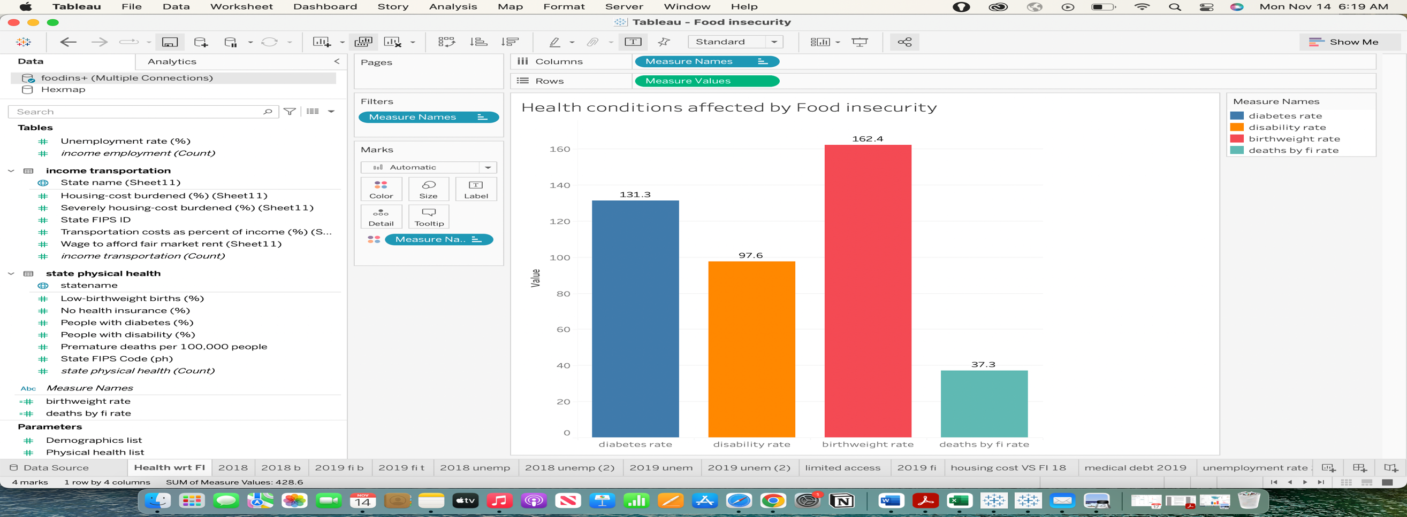

**Visualization 2 and 3**:

The two worksheets below provide information on the ten states with the highest rates of food insecurity in 2018 and 2019. The rate of food insecurity relative to the total population in each state is generated for these visualizations using the calculated field feature. I chose the horizontal bar charts for this computation since they are the most suited.

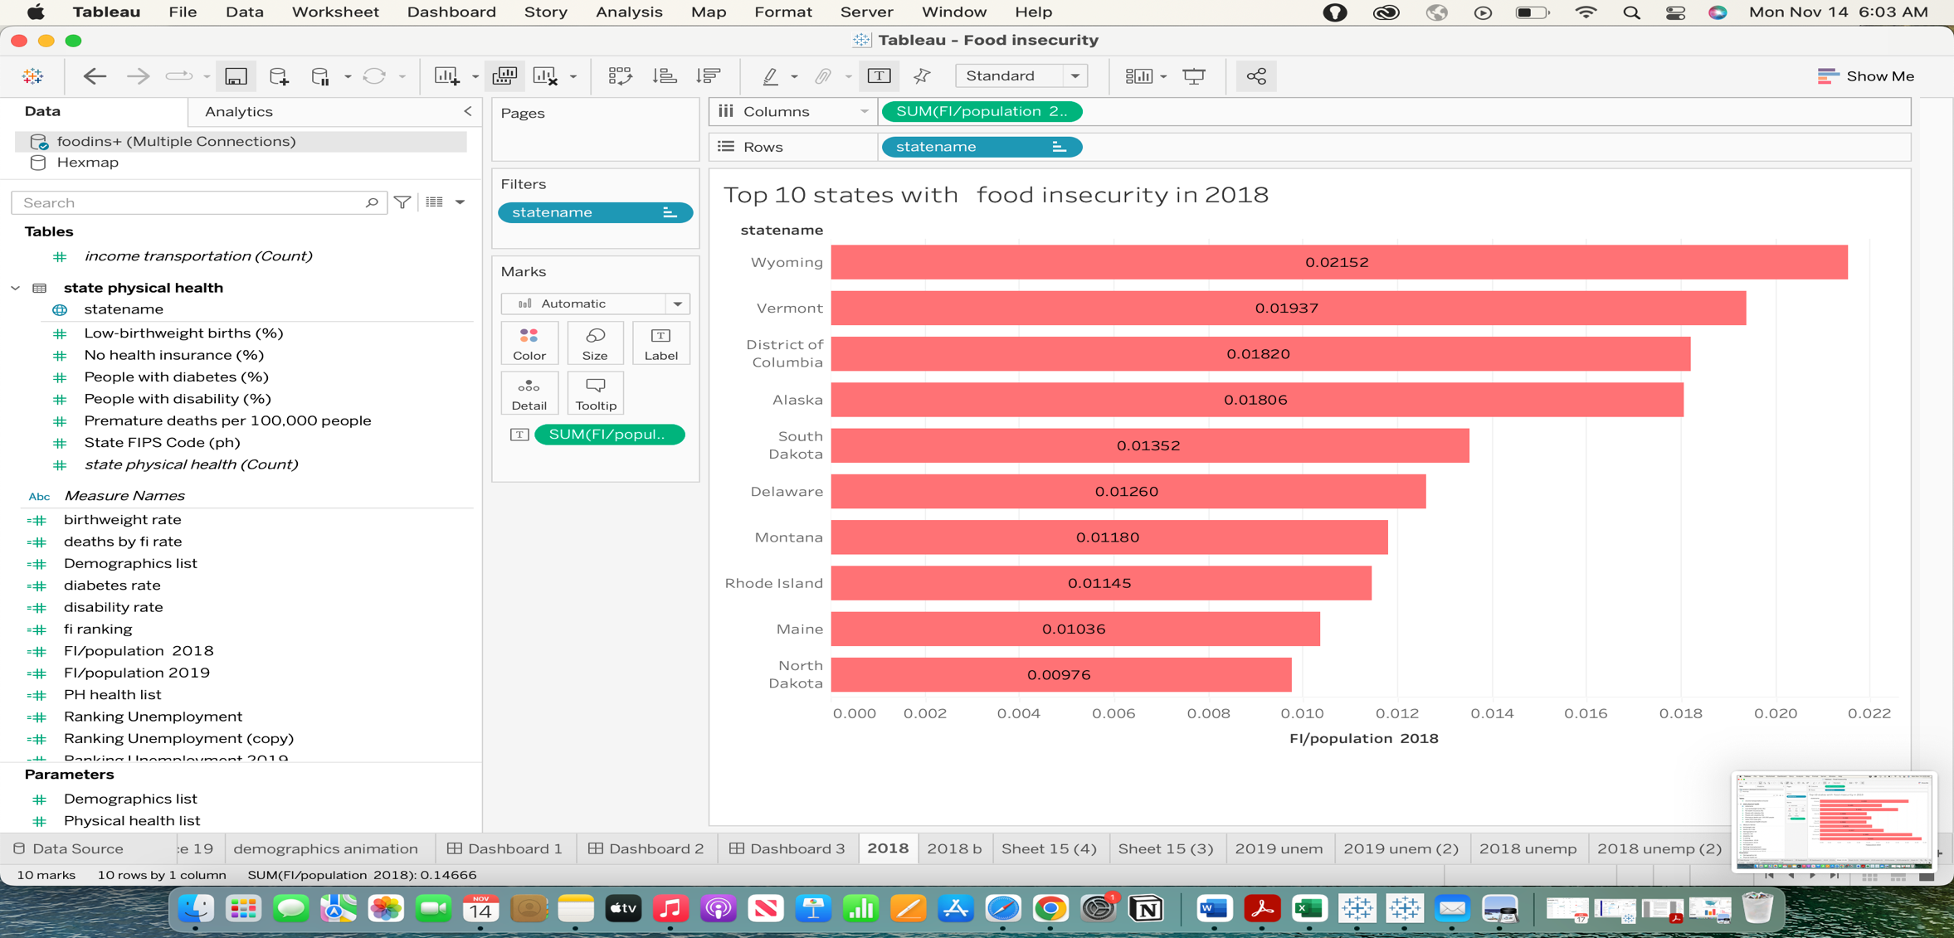

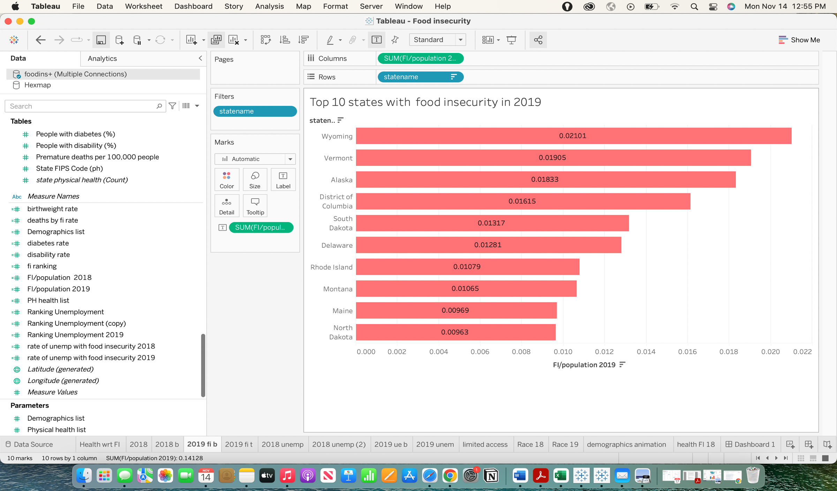

**Visualization 4 and 5 :**

We can visualize the bottom 10 states for food insecurity in 2018 and 2019 on the two worksheets below. These visualizations are carried out by taking into account the rate of food insecurity in each state relative to the entire population, which is derived using the calculated field feature. For better visualization, I used tree maps. To display the lowest 10 states, I've utilized the condition filter.

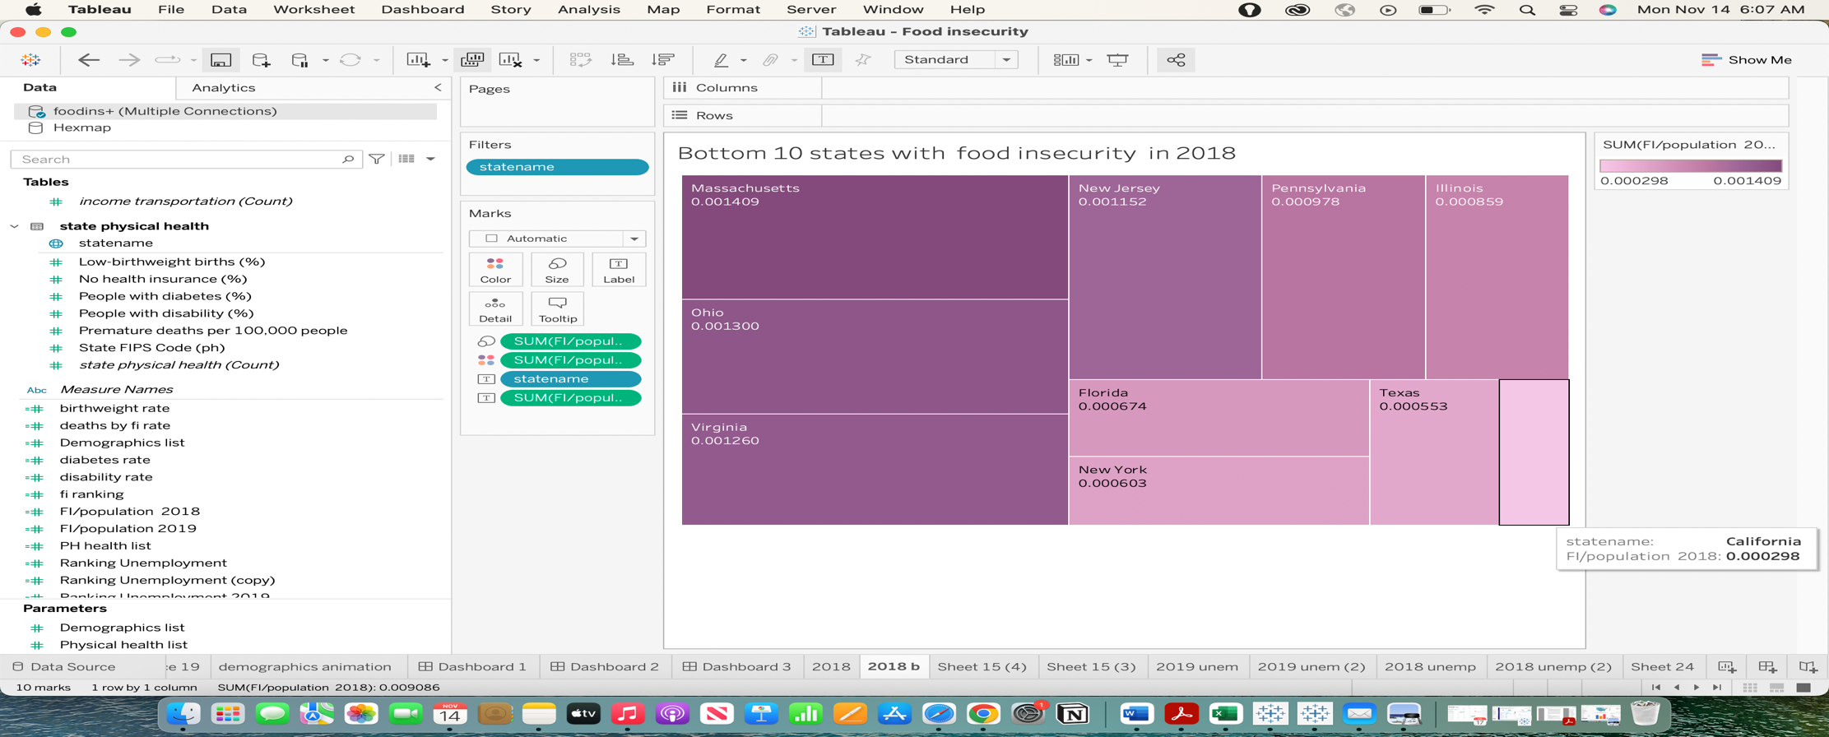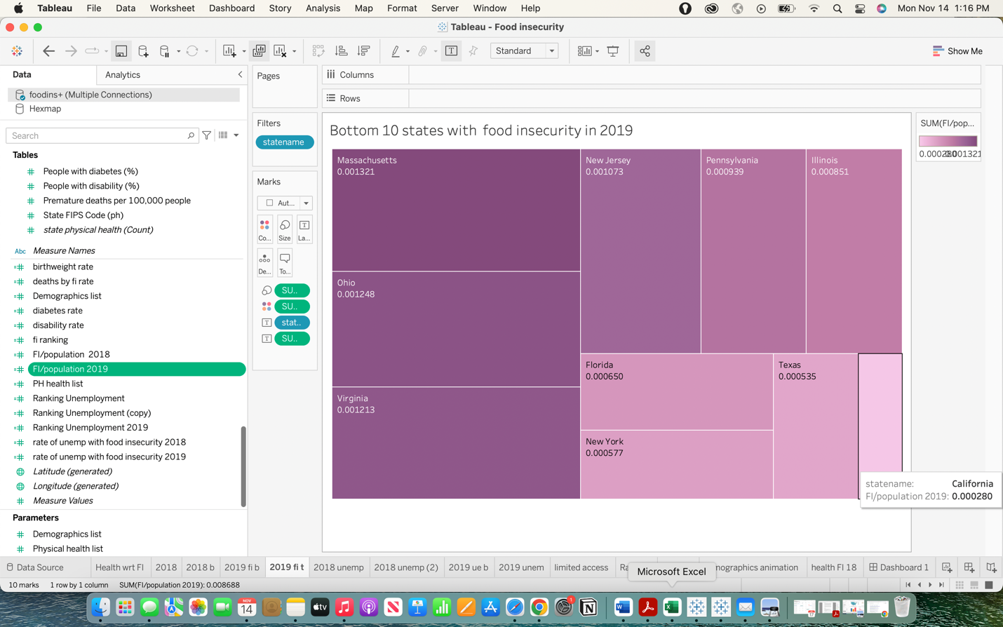

**Visualization 6 to 9:**

The four worksheets below provide a visual representation of the top and bottom five states in terms of food insecurity as a function of unemployment rates in 2018 and 2019. These visualizations are carried out by taking into account the unemployment rate and the rate of food insecurity in each state as estimated using the calculated field feature. To illustrate this, I've utilized packed bubbles and bar charts. Additionally, I have displayed the top and bottom 5 states using the filter by condition.

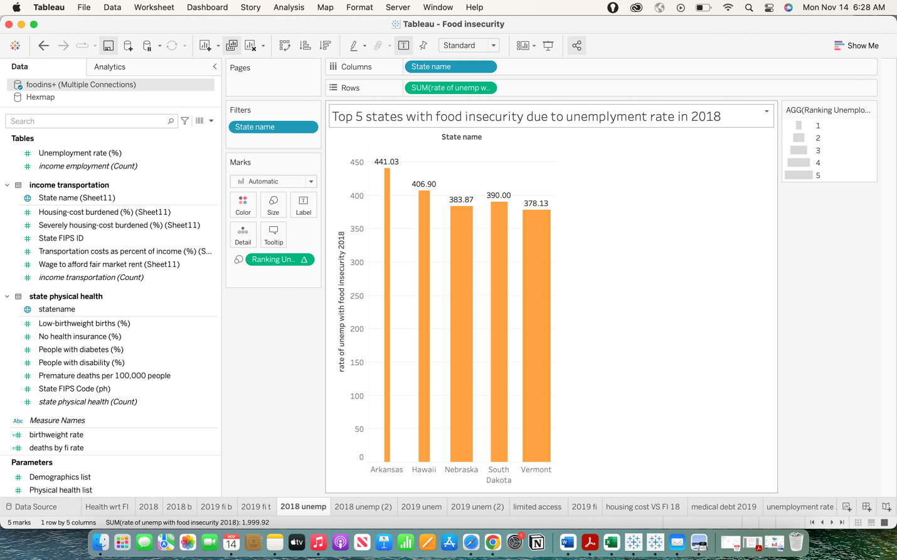

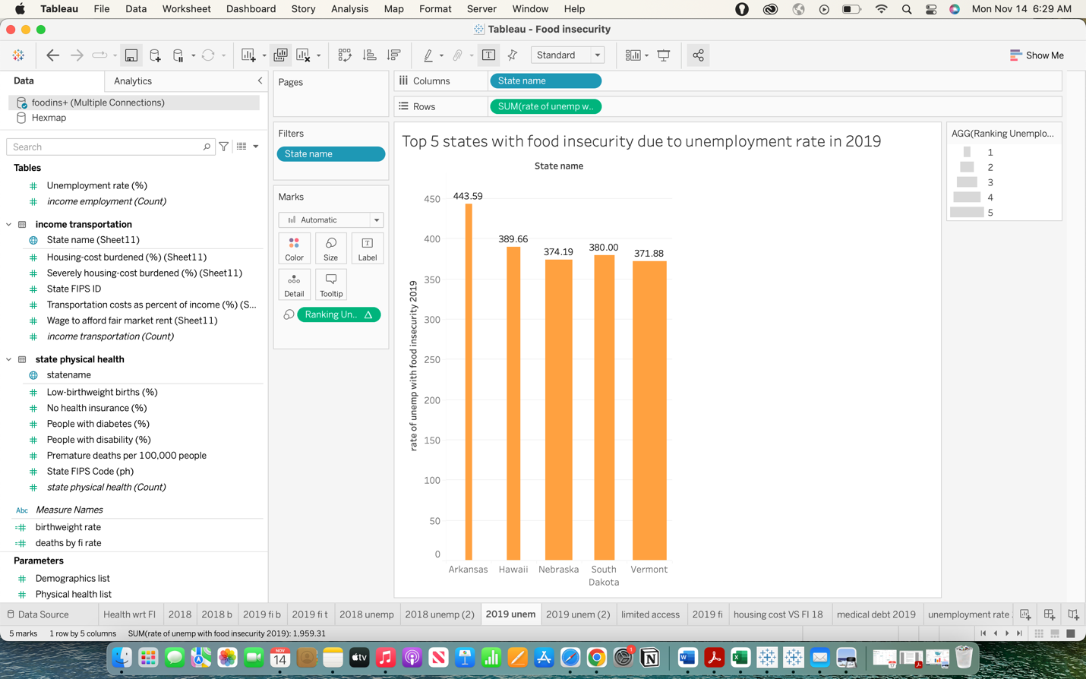

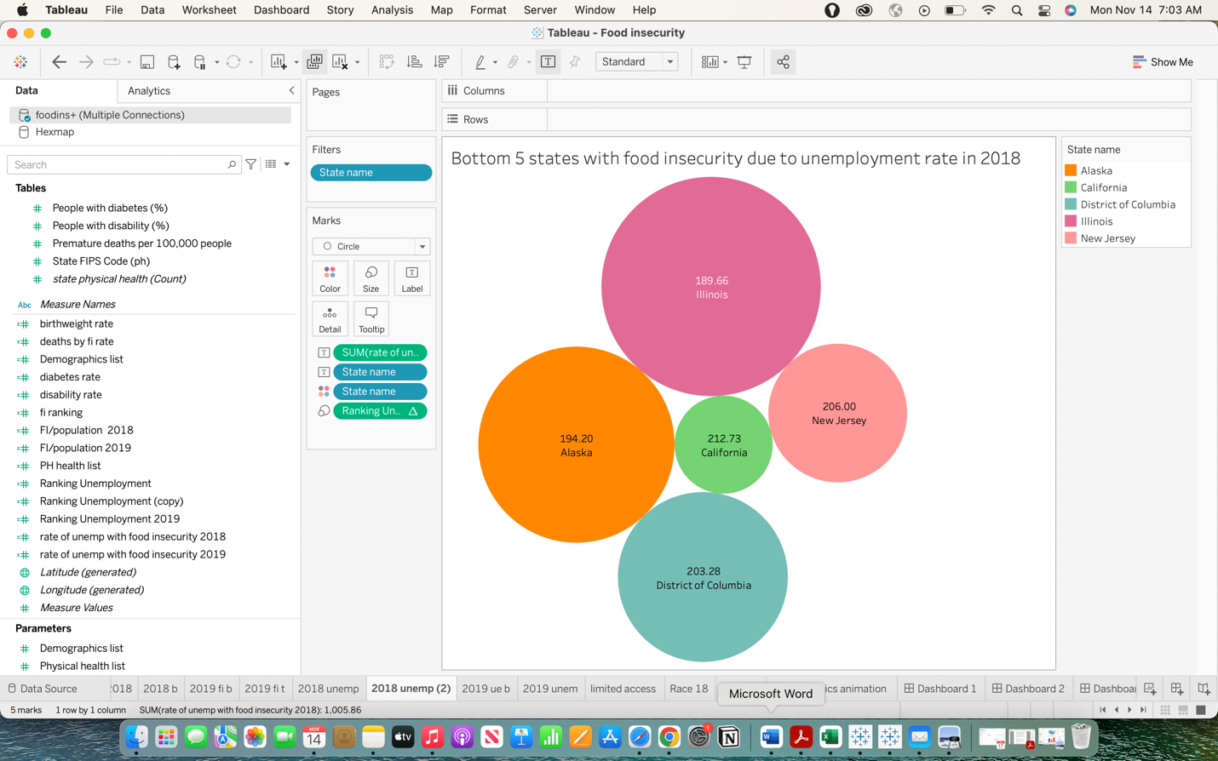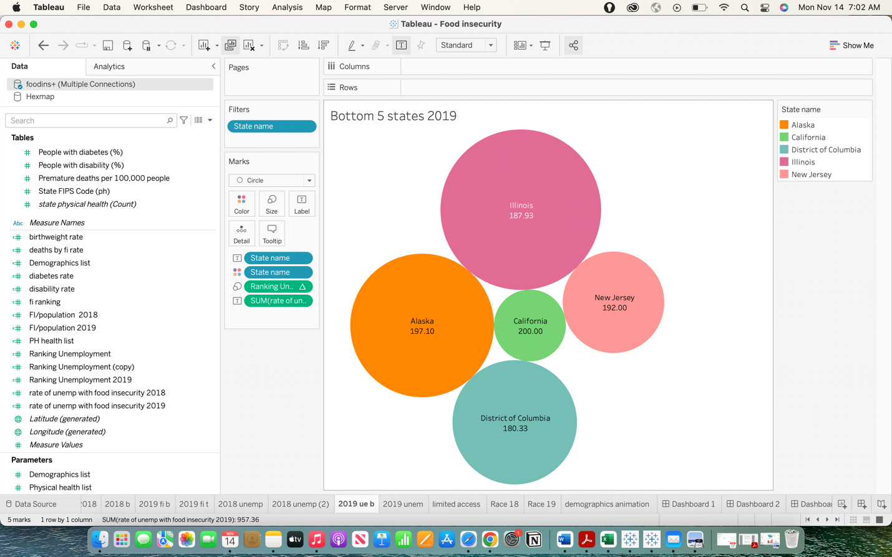

**Visualization 10:**

This worksheet helps us visualize the number of people who have restricted access to wholesome food(Healthy diet) in different states. Map has been utilized by me to do this.

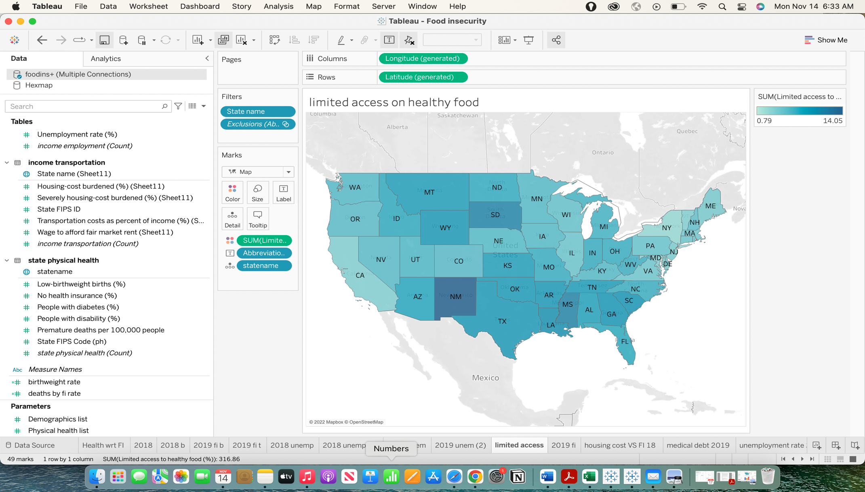

**Visualization 11 and 12:**

These worksheets tell us about food insecurity as it relates to people of many ethnicities. These sophisticated visualizations have drill-downs and animations, which have been produced using parameters and calculated fields, respectively.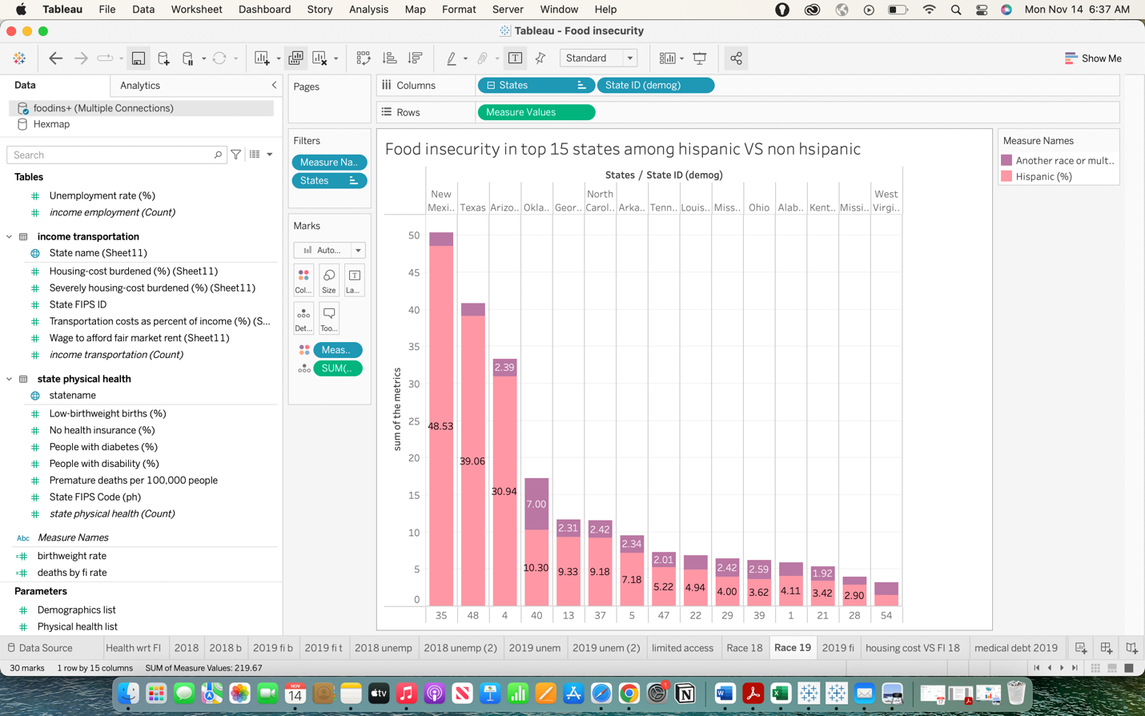

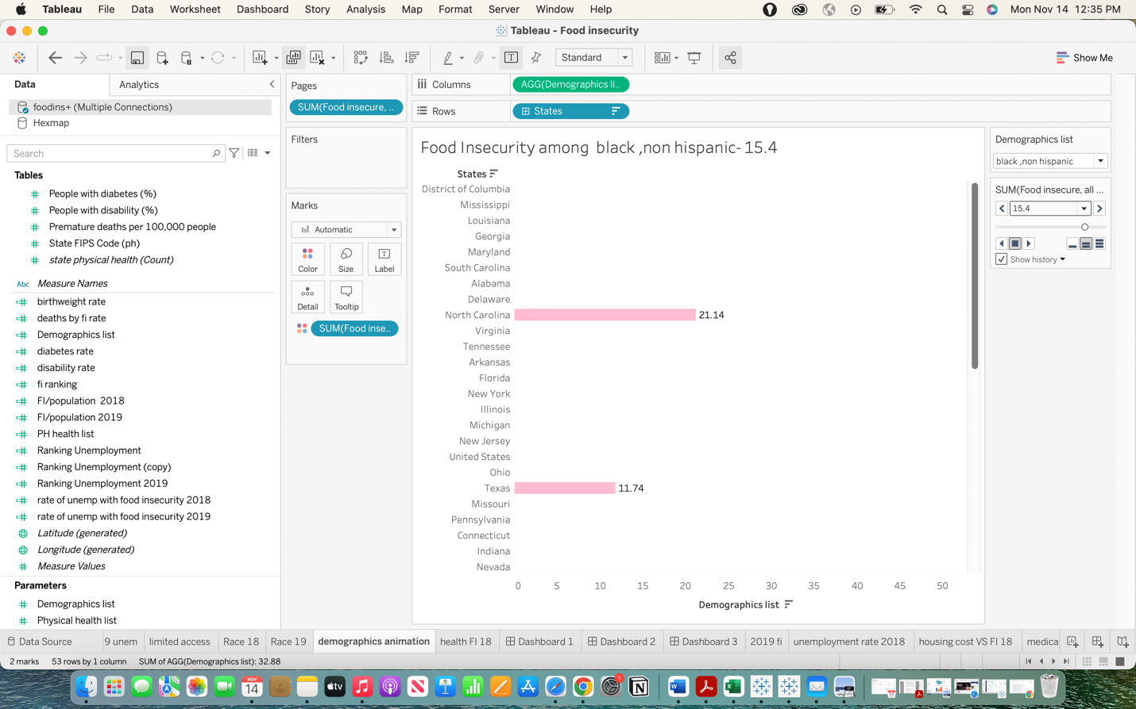

**Dashboards:**

In this project, I have developed three dashboards.

Information regarding the top and bottom 10 states with regard to food insecurity is provided by Dashboard 1.

Dashboard 2 provides data on the top and bottom 5 states where food insecurity is significantly impacted by unemployment.

Dashboard 3 provides data on food insecurities for people of diverse ethnic backgrounds, people with various physical health concerns, people with limited access to good food, and other variables that I may use to show significant metrics.

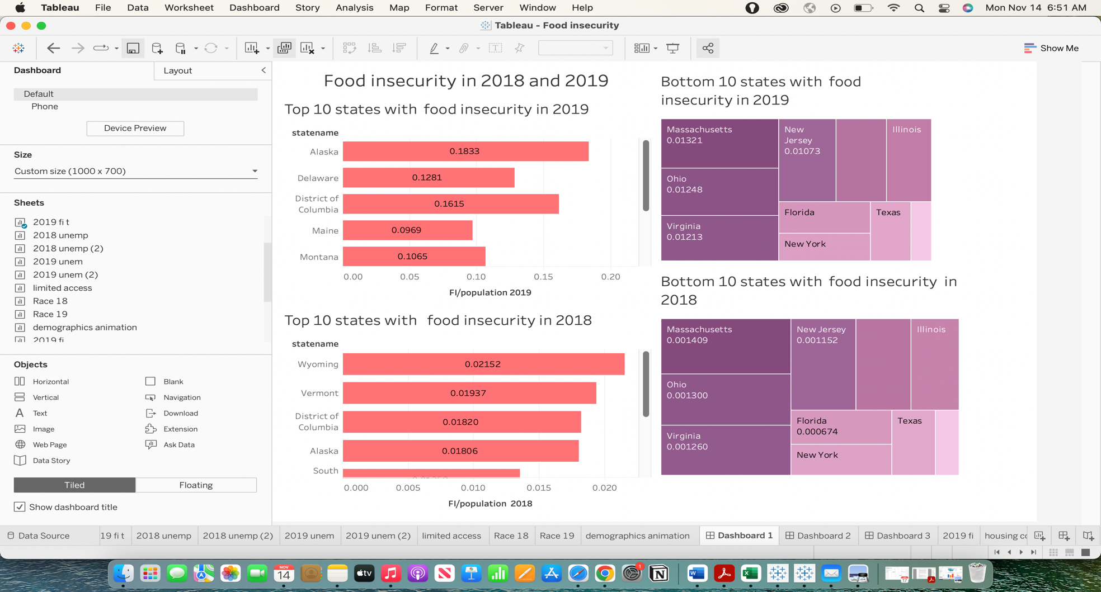

Figure Question 2 analysis

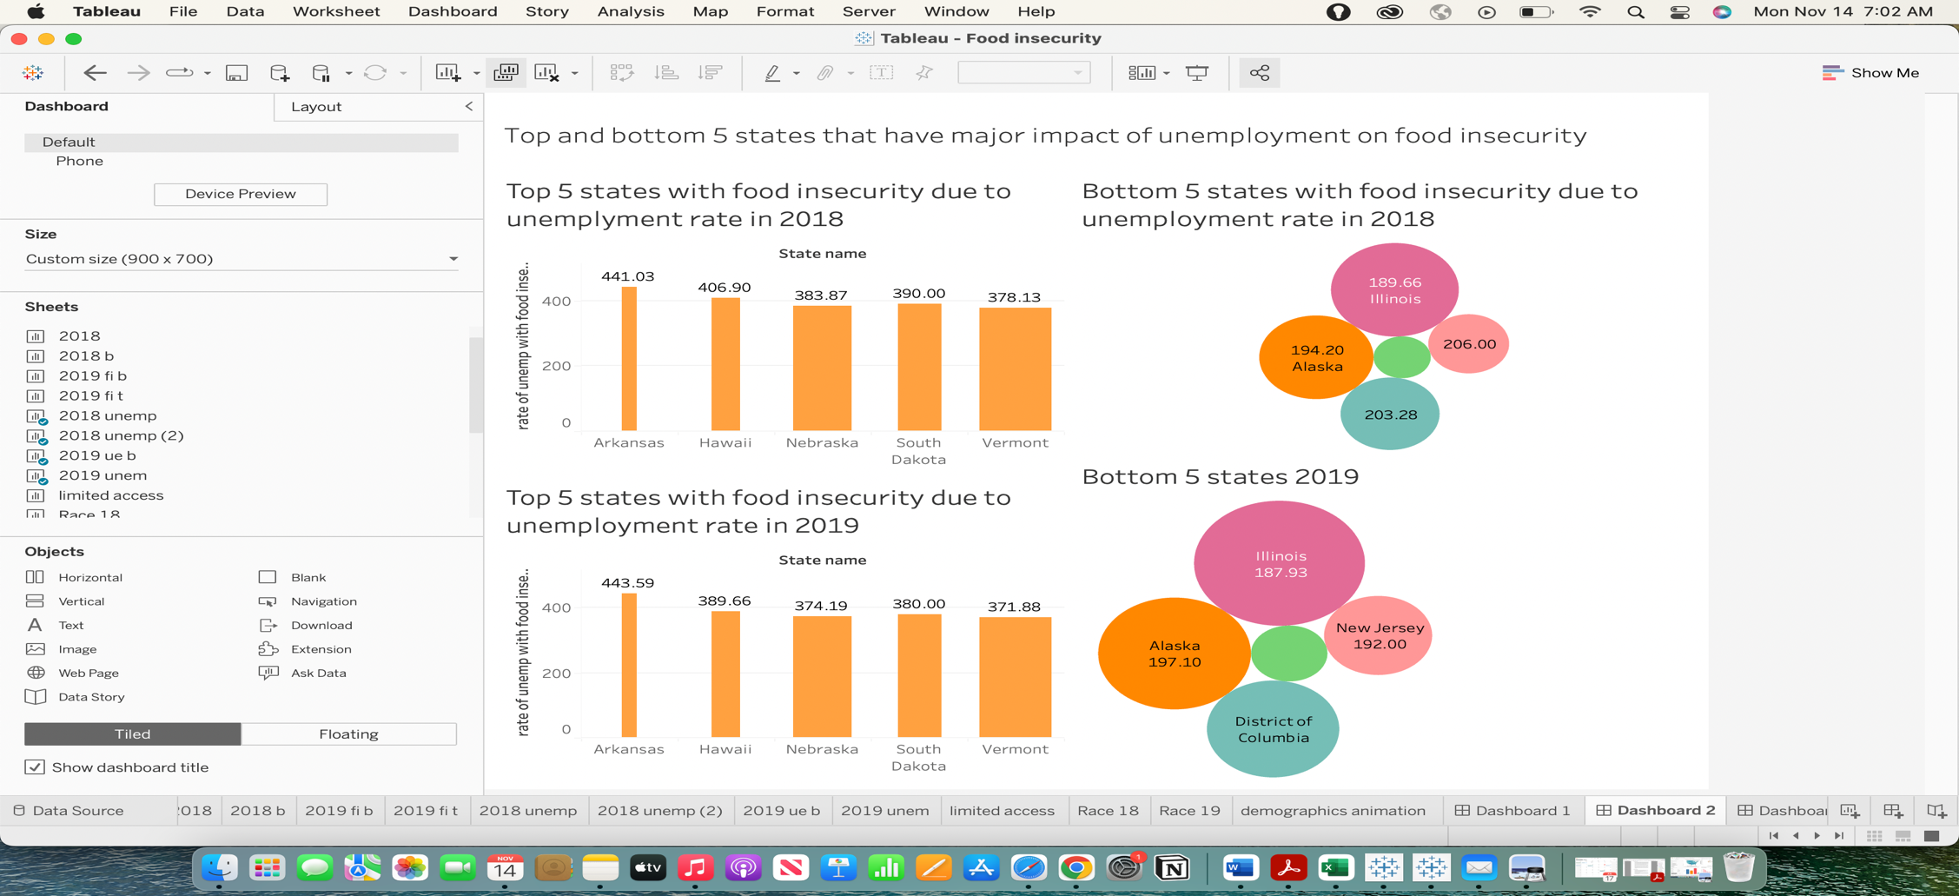

Figure Question 3 analysis

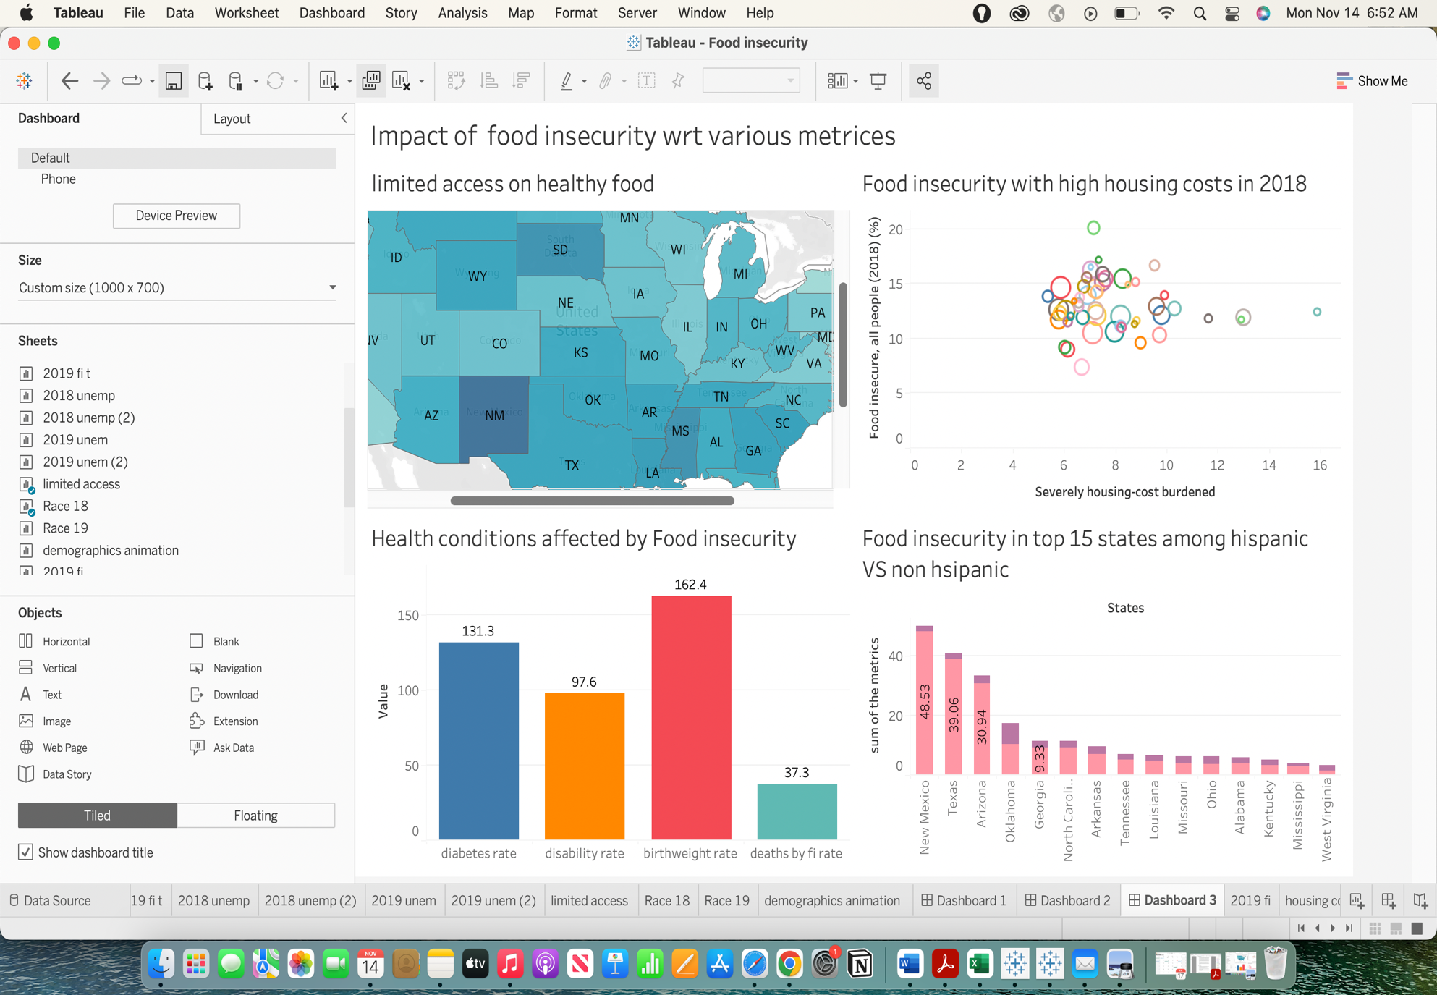

Figure Question 1 and other research questions

**Story:**

The narrative of this project gives any viewer or decision-maker an understanding of what states are experiencing major issues and what variables are affecting most, enabling them to take the necessary corrective action for the benefit of society.

**Conclusions:**

**Question 1:** How does food insecurity affect medical conditions. What health issue is the most impacted by food insecurity?

According to the visualization and analysis, a **high percentage** of low-birth-weight babies (162.4) is caused by food insecurity **since the moms won't have access to enough nutrients during pregnancy as a result of food shortage**.

Impact of food insecurity is a **131.3** percent rate for persons with diabetes, a **97.6** percent rate for those with disabilities, and a **37.3** percent death rate.

**Question 2:** Which are the top and bottom 10 states affected by food insecurity in both years?

1. **The top 10 states affected by food insecurity in both years are** :

Wyoming

Vermont

District of Columbia

Alaska

South Dakota

Delaware

Montana

Rhode Island

Maine

North Dakota

Wyoming, Vermont, the District of Columbia, South Dakota, Montana, Rhode Island, Maine, and North Dakota all had higher rates of food insecurity in 2018 than they did in 2019.

Compared to 2018, there is more food insecurity in Delaware and Alaska in 2019.

Interpretation:

This suggests that the effects of food insecurity have decreased in many states in 2019 compared to the previous year. There isn't a huge difference between the food insecurity rate, but it is a little better than the year before. The primary goal should be to lessen food insecurity.

1. **Bottom 10 states with food insecurity in the United States are :**

Massachusetts

Ohio

Virginia

New Jersey

Pennsylvania

Illinois

Florida

New York

Texas

California

A good improvement is that the rate of food insecurity is lower in all 10 states in 2019 than it was in 2018. Additionally, all the aforementioned states are very populous and significant, making them extremely secure against food shortages. It could be for several reasons, including access to decent healthcare, employment possibilities, and housing.

**Question 3**: Which are the top and bottom 5 states that have major impact of unemployment on food insecurity?

**Top 5 states:**

Arkansas

Hawaii

South Dakota

Nebraska

Vermont

Arkansas has seen an increase in the rate of food insecurity in 2019, whereas rates in the other four states are all lower than they were in 2018.

**Bottom 5 states:**

California

District of Columbia

New Jersey

Alaska.

Illinois

Alaska has seen an increase in the prevalence of food insecurity in 2019, while the rates in the other four states have all decreased during 2018.

All the states are well-known and significant states, making them quite secure against food shortages. Since there are many employment prospects in these states, many individuals can afford to buy food and other necessities.

**Summary:**

**Overall trends indicate that major cities have less food insecurity than small cities; therefore, efforts should be made to enhance minor city lifestyles so that citizens can lead respectable lives and afford necessities.**

**Other Research Questions**:

1.How is food insecurity among people with different ethnicities?

2. Is food insecurity high in rural or urban regions?

3. How many people can afford a balanced diet?

4. How is income of the household influencing the food insecurity?

I have created several advanced visualizations using maps, filters, drill downs, and parameters that can be found in my tableau workbook which will answer 2 of the above research questions.

**Tableau Workbook Explanation:**

There are multiple sheets in the workbook as I was analysing the trends for 2 years. But below are the sheets for easy reference with different visualizations:

**Sheet names for simple visualizations :**

1. Health

2. FI 2018 T

3. FI 2018 B

4. UNFI 2018 B

5 FI 2019 - ( used hex map concept)

**Sheet names for advanced visualizations :**

1. Ethnicity. - ( drilldowns)

2. health FI 18 - ( parameters)

3. UNFI 2018 T. - ( filter states based on conditions, ranking )

4. ethnicity animation- (parameters and calculated field)

**Animations and maps :**

1. limited access

2. ethnicity animation

3. Ethnicity 2019 - (animation)

Thus I have answered the research questions and explored the given set.